Yann Gourvennec: English biography
update date :14/09/2019
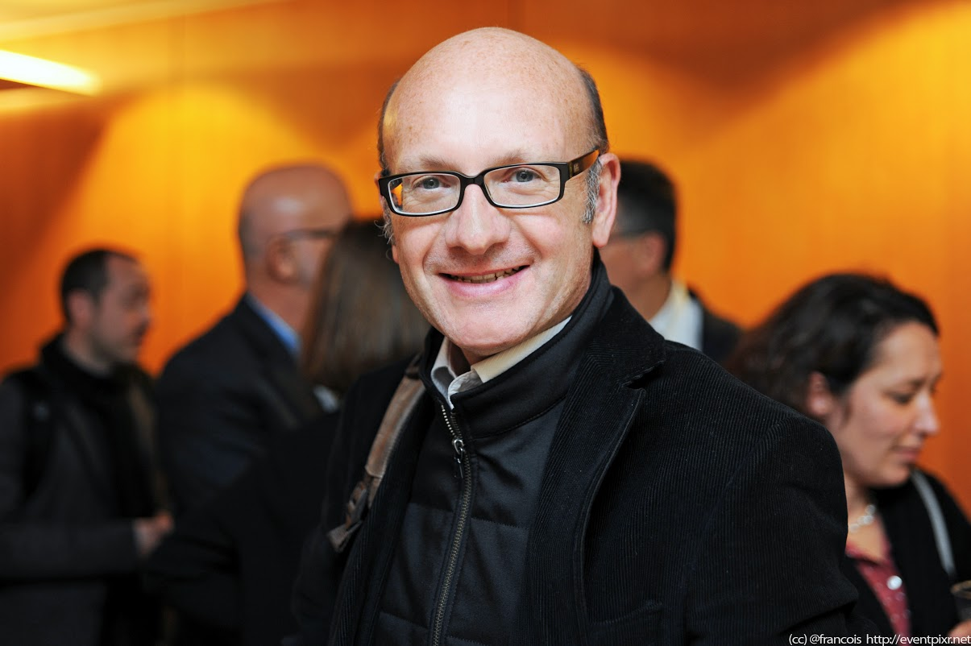

Yann Gourvennec has a long-standing experience in marketing, information systems and Web marketing. He created visionarymarketing.com in 1996 and since then, he has practiced Web strategy, e-business and Web communications in the field. He has been a member of socialmedia.org from 2008 till 2013 and he co-founded Media Aces, the French Association for enterprises and social media. He is a lecturer, a keynote speaker, an author and blogger. He is the co-author of Mastering Digital Marketing Like A Boss, (http://like-a-boss.co). In early 2014, he went from intrapreneur to entrepreneur when he founded his digital marketing agency Visionary Marketing. Since early 2014 he served many clients including Business & Decision, EZ Systems, Mobistar, Orange, CIH Bank, Solocal group, SFR Business &Veolia.

Twitter: @ygourven & @vismktg

LinkedIn: http://linkedin.com/in/ygourven
Online profile: http://about.me/ygourven
Facebook: http://facebook.com/ygourven
English Blog: http://blog.visionarymarketing.com
Pictures: https://picasaweb.google.com/ygourven/YannSPhotos#

